Homework 2

**Part 0: Warmup**

1. What is the slash notation representation of 255.255.255.0?

/24

1. What is the dot-decimal representation of /30?

255.255.255.252

1. What is the smallest subnet size that would accommodate 5 hosts?

255.255.255.248/29

3 bits is needed for the subnet size. 2^2+2^1+2^0 = 7

The smallest subnet size is 7.

1. Fill in the blank cells in the table below

3 hosts-> 255.255.255.x/y

Need 3 IP addresses + the 2 reserved addresses (broadcast and network addresses), meaning 5 IP addresses are needed. Because IP addresses are distributed in powers of two, 8 IP addresses must be taken.

X = 8 -> 255.255.255.248

Y = 2^3 -> 32-3 = 29

|  |  |
| --- | --- |
| VM (interface) | IP Address (CIDR Notation) |
| R1 (eth0) | 10.10.10.1/29 |
| R2 (eth1) | 10.10.10.2/29 |
| Kali (eth0) | 10.10.10.3/29 |

Network address is 10.10.10.0/29

Broadcast address must be 10.10.10.7/29 (The largest address size provided)

**Part 1: Configuring Network Interfaces**

Open a terminal window (Applications > System Tools > MATE Terminal) and issue

the following commands on both R1 (eth1) and R2 (eth0): (Read Basics and Zebra of

FRR User Manual)

sudo su

vtysh

configure terminal

interface <interface name> // interface name can be eth0, eth1, or eth2

ip address x.x.x.w/29 // i.e. IP address and subnet mask (i.e. 192.0.2.130/30)

end

write

exit

You may use Linux’s ifconfig command in order to verify that you have saved your

network configuration (see man ifconfig)

R1 configuration:

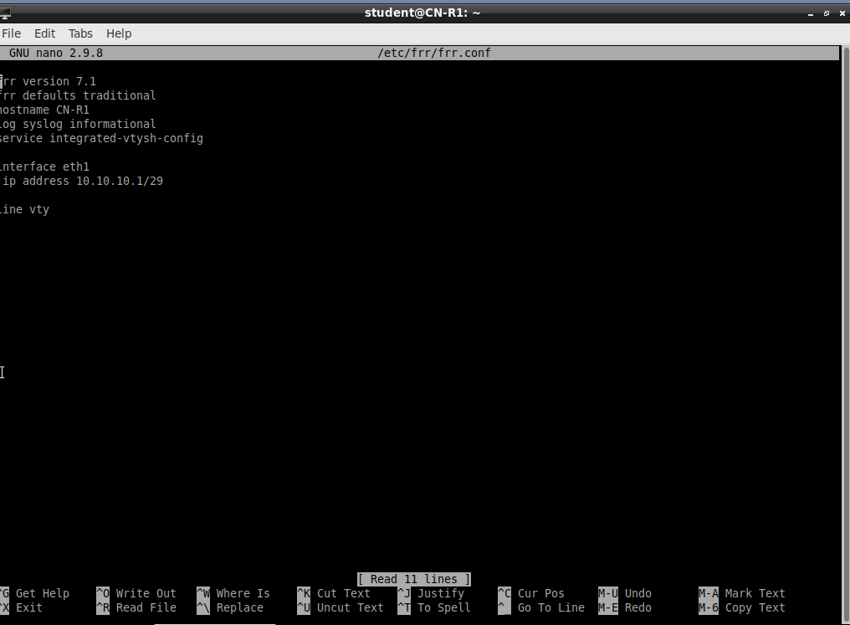

**R2 configuration**:

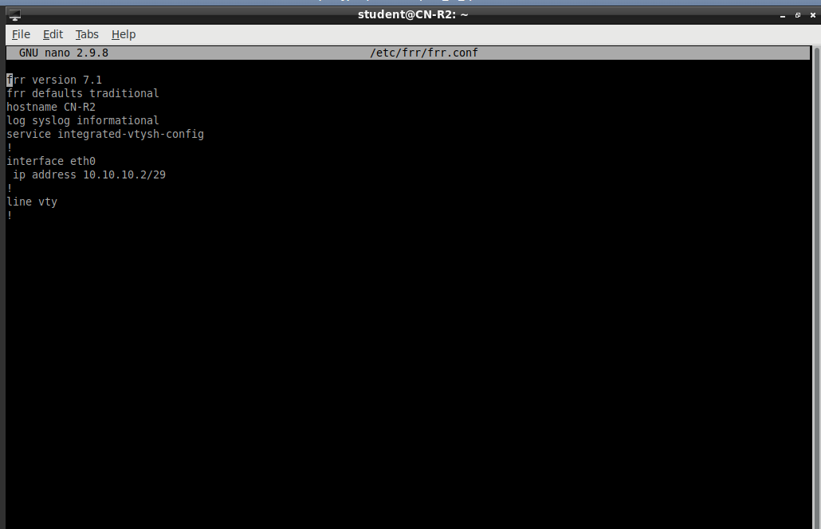

**Part 2:** Configuring Kali

Kali must be configured using the Linux commands:

**sudo su**

**nano /etc/network/interfaces (or nano/vi/vim)**

**Your configuration file should have the following entries:**

**auto eth0**

**iface eth0 inet static**

**address x.x.x.w**

**netmask A.A.A.B // convert your netmask to octet notation**

**network x.x.x.y**

**broadcast x.x.x.z**

**Once you have finished, reboot Kali**

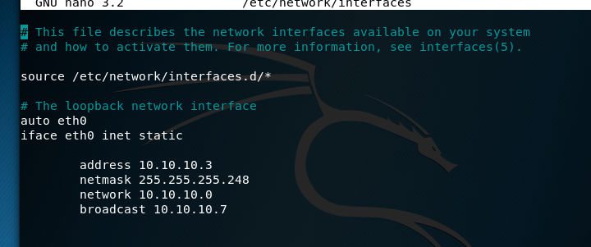

Will be using

auto eth0

iface eth0 inet static

address 10.10.10.3

netmask 255.255.255.248 // convert your netmask to octet notation

network 10.10.10.0

* Network Address must be the first address in the network, matching the subnet[1]

broadcast 10.10.10.7

* The broadcast address must be the last address in the network[2].

**Part 3**

1. Why did we choose the /29 subnet mask for Area 0? (10 points)

/29 has a set of 8 IP addresses and uses 1/32 of the class C networks. This is the minimum amount that can be used for 3 hosts because, in addition to the 3 hosts, another 2 IP addresses need to be reserved for the broadcast address and the network address. A total of 5 IP addresses are necessary for the network.

/30 can’t be used because it has a netmask of 255.255.255.252. This isn’t enough for the 5 IP addresses needed.

1. The Linux arp (see man arp) command will print the current entries in the machine’s address resolution protocol table. Now that you have configured Area 0, what entries are currently in R1, R2, and Kali? (10 points)

An ARP entry starts off empty and adds entries as requested from the machine. This is because the ARP tables are maintained dynamically. As a result, all machines (with the exception of R1) will start off empty when booted on.

R1:

R1 contains the IP address of 10.20.1.1 because it was preconfigured with that address for interface eth0.

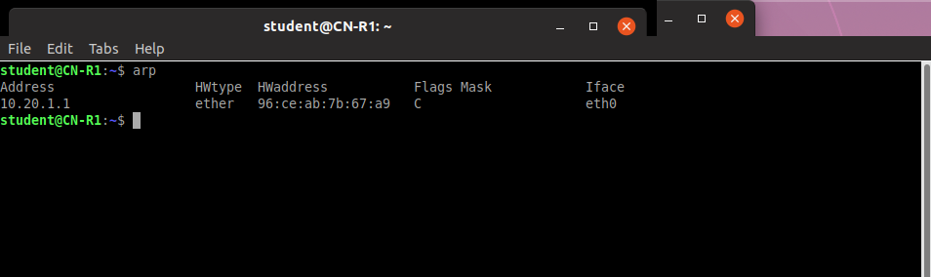

R2:

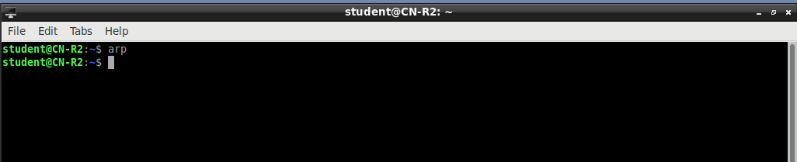

R3:

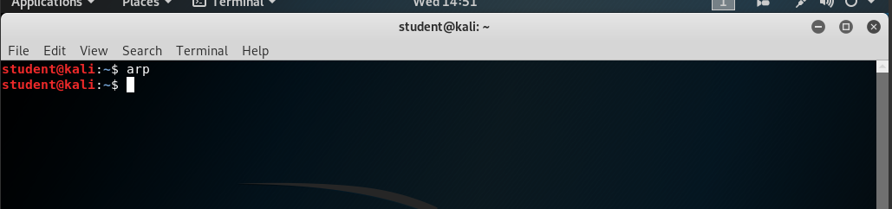

1. Now ping both R2 and Kali from R1. Note the changes on each machine’s arp table. At this point, R2 should be aware of Kali, but why doesn’t R2 have a table entry for Kali? (10 points)

Pinging Kali and R2 from R1.

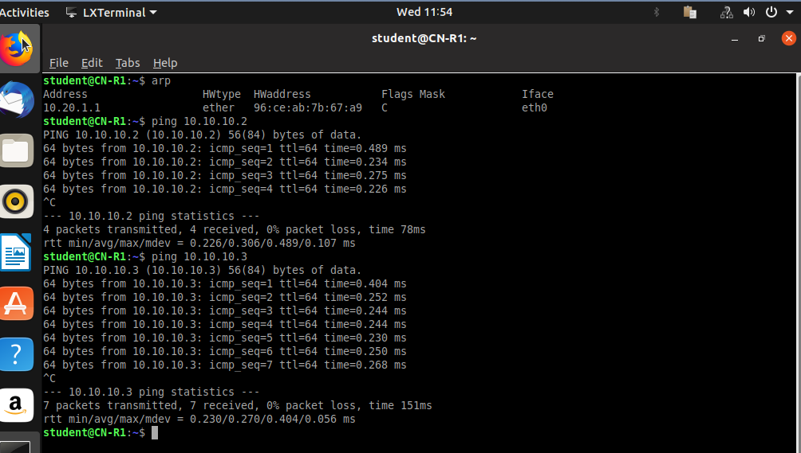

**R1’s new arp table**

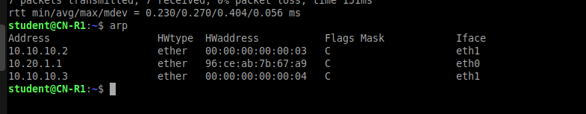

R2’s arp table

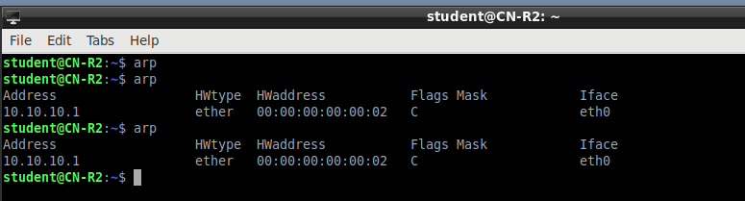

Kali’s arp table

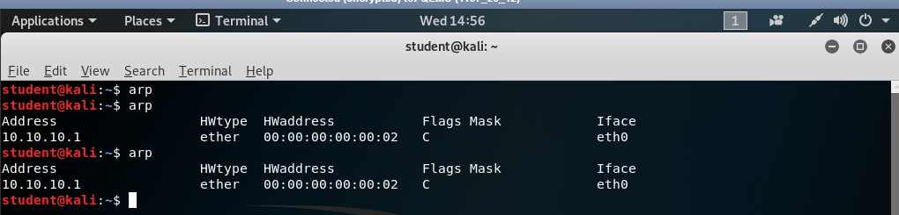

* why doesn’t R2 have a table entry for Kali?

The ARP request is a broadcast message sent to all machines within a network. The ARP Reply is sent directly to the machine that sent the ARP Request message. According to Wireshark, the R2 machine will read R1’s arp request for Kali, but it will never detect Kali’s ARP response. This is because while the ARP request is broadcasted, the ARP response is unicast and sent directly to the client that sent out the ARP request.

R2 will read R1’s ARP request, but Kali will send the ARP response directly to R1. R2 will not receive Kali’s ARP response to R1.

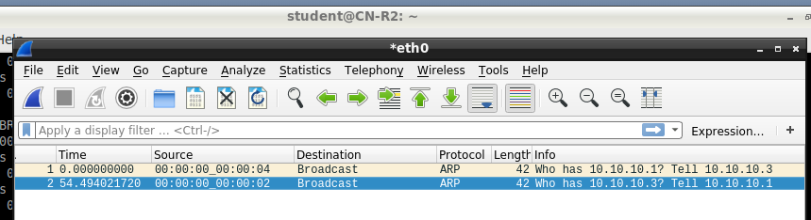

[30 pts] Screenshot of the .conf file under /etc/frr/frr.conf from R1 and R2.

R1’s conf file

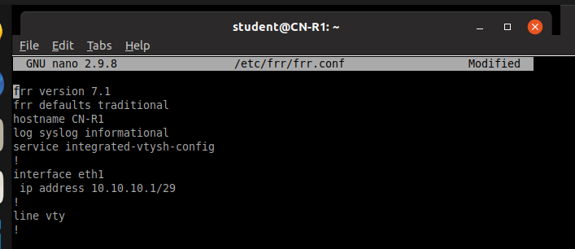

R2’s conf file

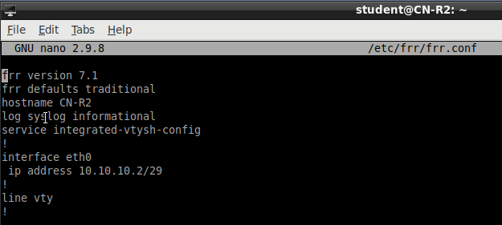

[10 pts] Screenshot of the /etc/network/interfaces file in Kali.

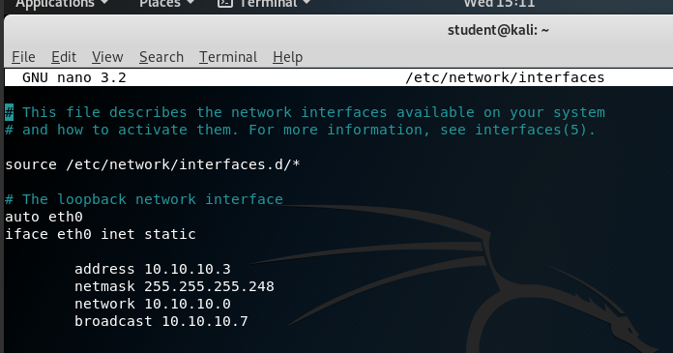

[20 pts] Screenshot showing that pinging works between R1, R2, and Kali.

R1’s pinging

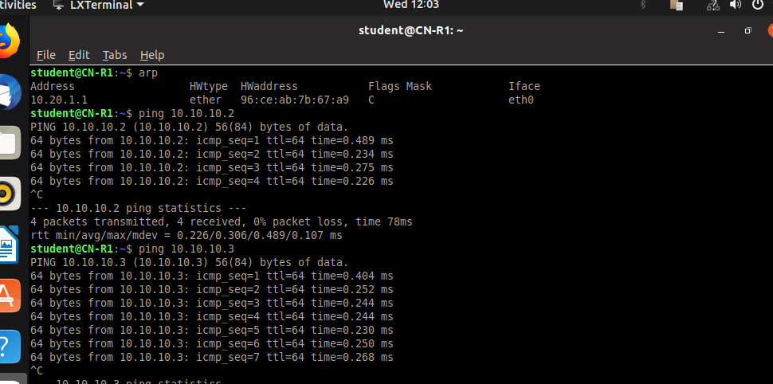

R2’s pinging

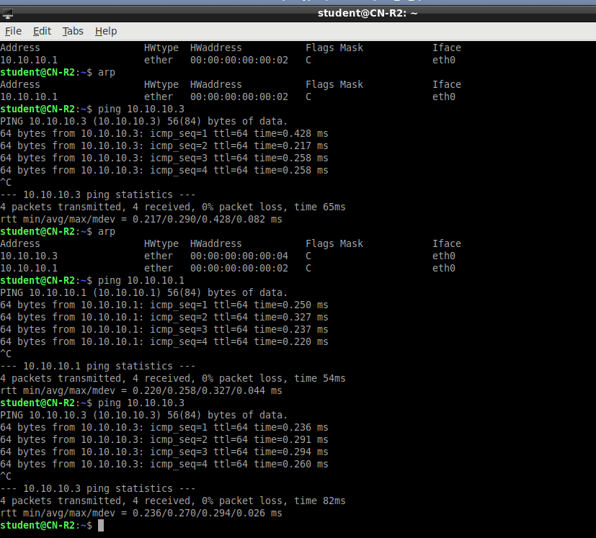

**Kali’s pinging**

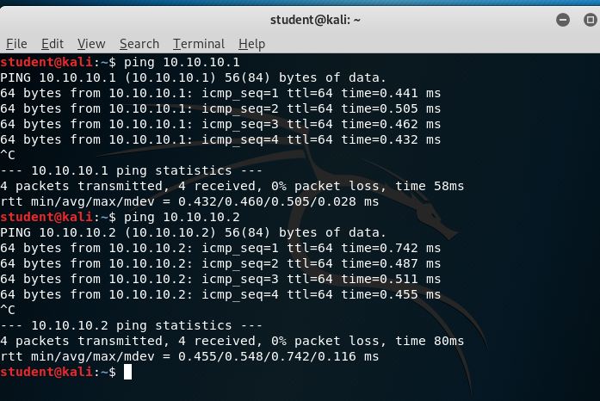

[10 pts] Screenshot of the ARP tables on R1, R2, and Kali.

These arp tables were after all 3 machines pinged each other.

**R1’s arp table**

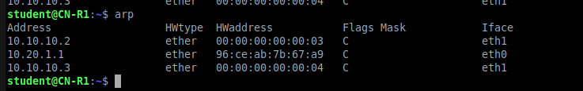

**R2’s arp table**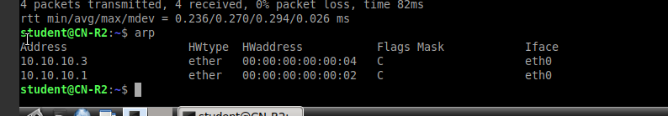

**Kali’s arp table**

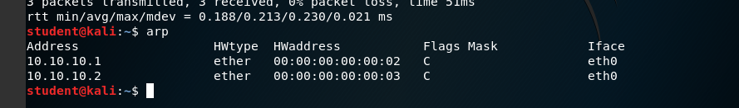

[30 pts] Answers to questions 3a-3c

1. http://ladu.htk.tlu.ee/erika/taavi/doc2/network_and_broadcast_address.html#:~:text=Broadcast%20address%20is%20the%20last,remote%20announcements%20in%20network%20segment.
2. http://ladu.htk.tlu.ee/erika/taavi/doc2/network_and_broadcast_address.html#:~:text=Broadcast%20address%20is%20the%20last,remote%20announcements%20in%20network%20segment.